The Ellen Garrison Scholarship

Application for Eligibility

Type or print all requested information, then send to the email below with your essay and video. Please be sure to save as a Word document. (If you use Pages on a Mac, please convert to MS Word before sending.) You will receive email verification that your materials are readable and viewable once reviewed by the Scholarship Administrator.
All application materials must be received via email no later than June 28, 2024.

Important: ALL fields must be filled in to complete the application.
(Incomplete applications cannot be considered.)

PART I: APPLICATION
Personal Information

First Name: MI: Last Name:

Date of Birth: Gender:

Mother’s Name: Father’s Name:

Are your parents:* Married_____ Separated_____ Divorced_____ Other______________

Number of Brothers/Sisters:* Parent(s)’ Annual Income:*

Mailing address: Street: Apt. #
City: State: Zip Code:

Telephone: Email:

* These three questions are asked in support of determining the student’s financial need.

Academic Information

Final Cumulative Grade Point Average at Concord Carlisle High School:

Post High School Academic Plans: College______ Vocational______ Other_________
What college, university or vocational school do you plan to attend this fall?

What is your planned program of study or major?

Important: All information you provide will be held in strict confidence and deleted once the scholarship has been awarded.
Extracurricular Activities and Other Interests

If you were involved in any extracurricular activities (sports, arts, clubs, etc.) during high school, please list them:

What other interests do you have that inspire you, strengthen you or just make you happy?

Who are some of your “heroes” and people you admire?
T-shirt size (Gildan softstyle cotton jersey t-shirt, unisex—sizes run small):
S____ M____ L____ XL____ 2XL____

Front: | Back:
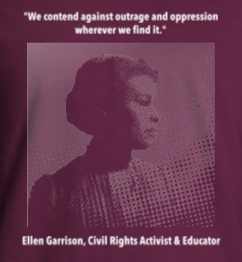 | 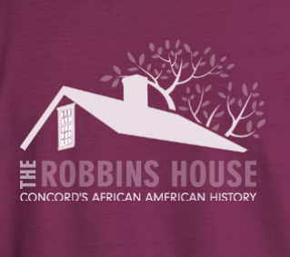

PART II: ESSAY and VIDEO

Essay

In a separate document or continuing pages in this application, please type a 500-word essay, double-spaced, on the following topic:

Describe how Ellen Garrison or a similar advocate for education and civil rights has inspired you as a student of color, and shaped the educational and social experience you had in Concord’s public schools.

Video

Create a two-minute video introducing yourself and highlighting the main points of your essay.
- What did you learn that was the most meaningful to you during your time in Concord?
- What challenges did you face and were you able to overcome them?
- And what do you most look forward to now?

Remember to talk about your truth—how you really feel about your education and experience. Both the essay and video are all about you and who you are, and we can’t wait to meet you!

Submission Instructions:

- Please send the application and essay in one email with the subject “Application”.
- Then send the video in a second email (due to size) with the subject “Video”.
Please make sure to email both to the email address below no later than June 28, 2024.
The selected award recipients will be notified by email and phone on July 4, 2024.

Please send all application materials to: EGarrison1823@gmail.com

